AI-Enabled Water Well Predictor

In this project by using water well dataset you ask to develop following machine learning models

1. K-means clustering: implement clustering algorithm to group similar points for aqua dataset and this algorithm will group all states with less water in one cluster and states with high water in other cluster
2. Classification models: employed decision tree and random forest algorithm to predict water bearing level zone
3. Regression Models: employed decision tree and random forest algorithm to forecast water level in wells
4. Visualization: employed various graphs to understand water consumption for industrial and domestic purpose
5. NLP analysis: application will take feedback from user and then employed NLP algorithm to predict user sentiments from feedback

To implement this project we have designed following modules

1. User Sign up: new user can sign up with the application
2. User Login: user login to system
3. Visualization: after login user can run this module to generate various visualization graphs
4. Clustering: can run this module to cluster all dataset and then plot data points with high and low water resources area
5. Train ML Model: train classification and regression models to predict forecast current water level and to predict water well level
6. Current Water Level: use this module to enter well details and then algorithm will forecast current water level
7. Water Bearing Zone: use this module to enter well details and then algorithm will predict well water level
8. Feedback: user can write feedback and then NLP will analyse feedback to know about user patterns as sentiments

SCREEN SHOTS

To run project double click on ‘run.bat’ file to start python server and get below page

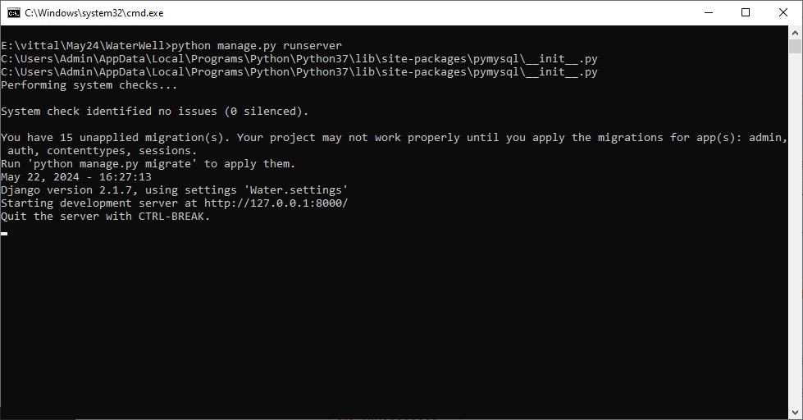

In above screen python server started and now open browser and enter URL as <http://127.0.0.1:8000/index.html> and press enter key to get below page

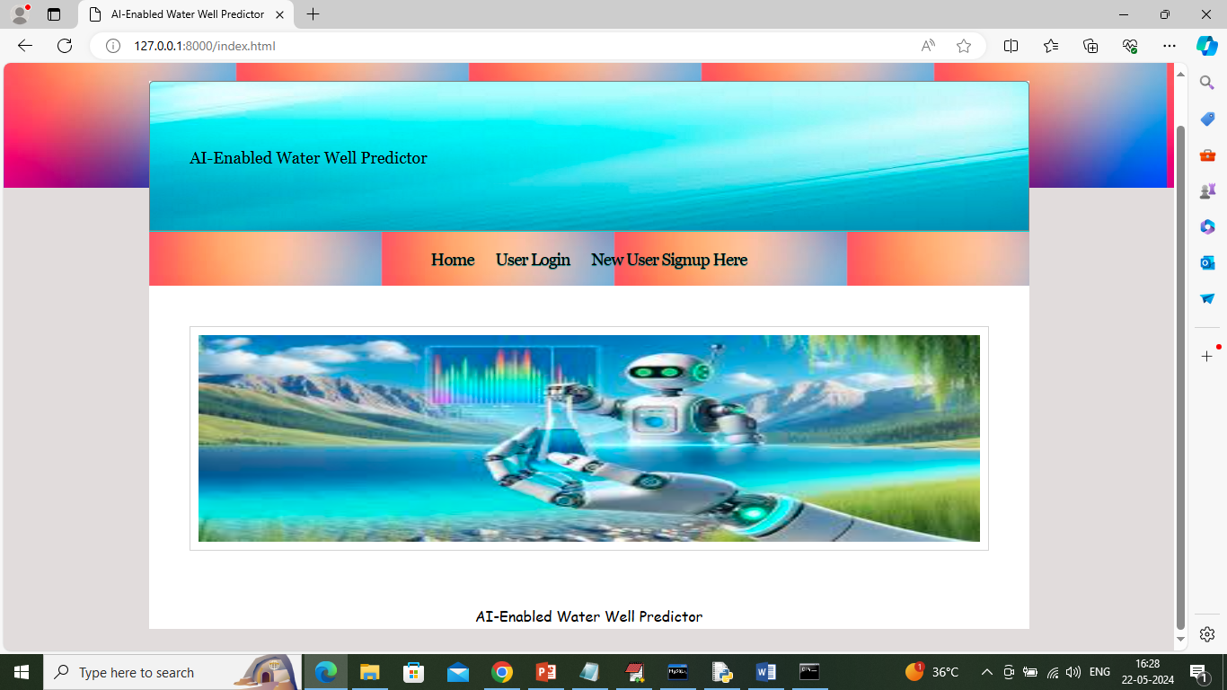

In above screen click on ‘New User Sign up’ link to get below page

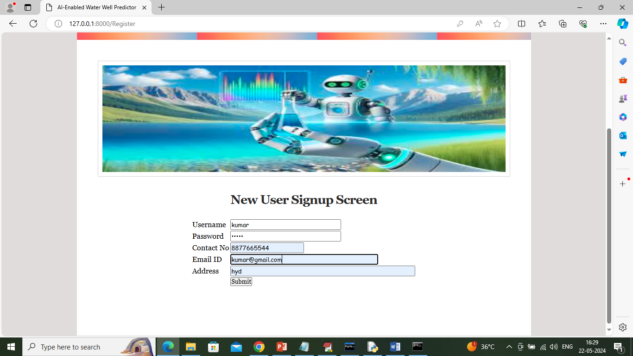

In above screen user entering sign up details and then press button to get below page

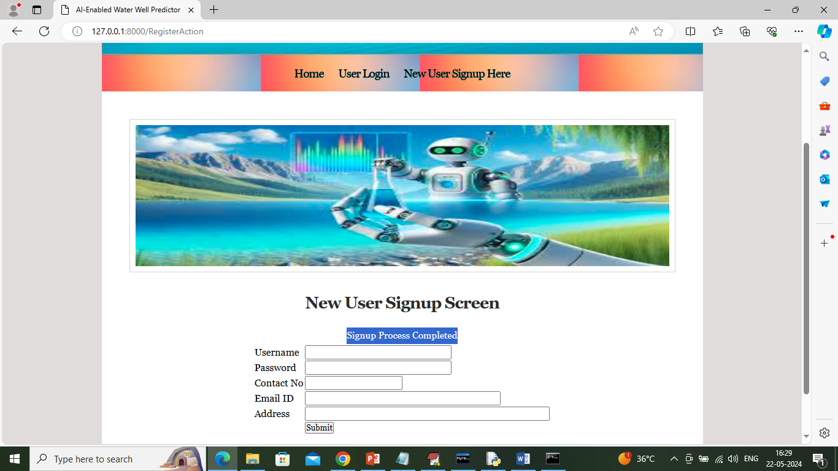

In above screen sign up completed and now click on ‘User Login’ link to get below page

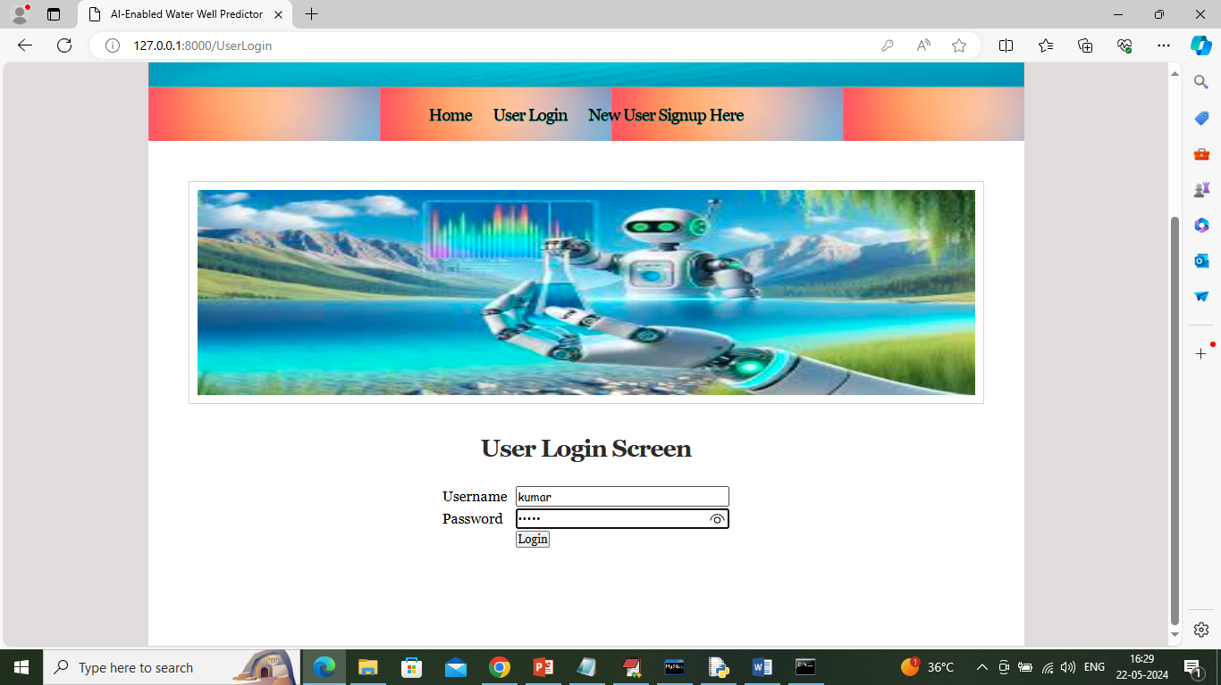

In above screen user is login and after login will get below page

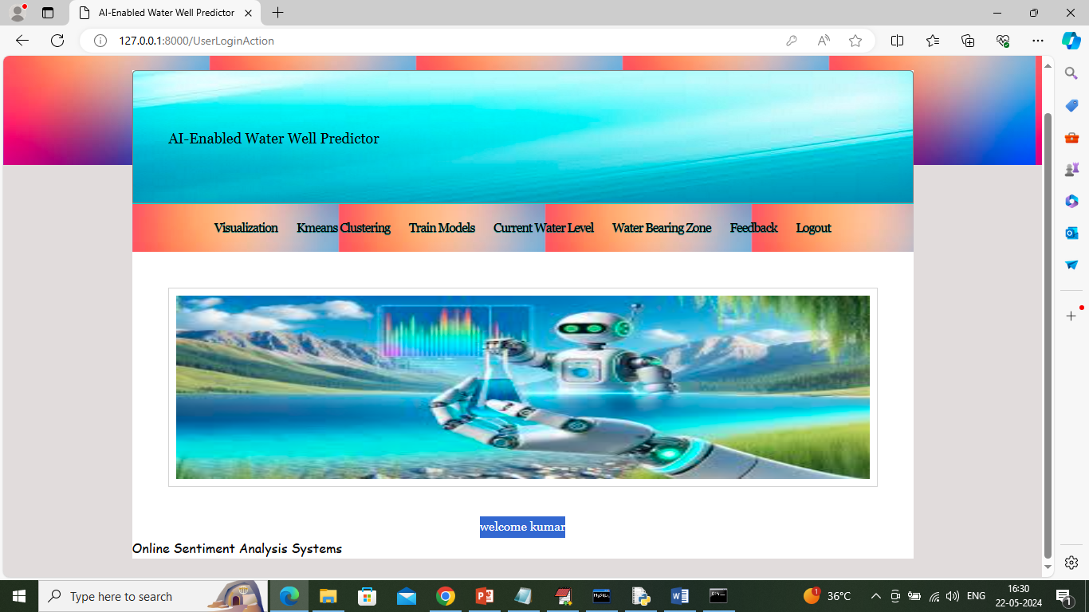

In above screen user can click on ‘Visualization’ link to visualize dataset and get below page

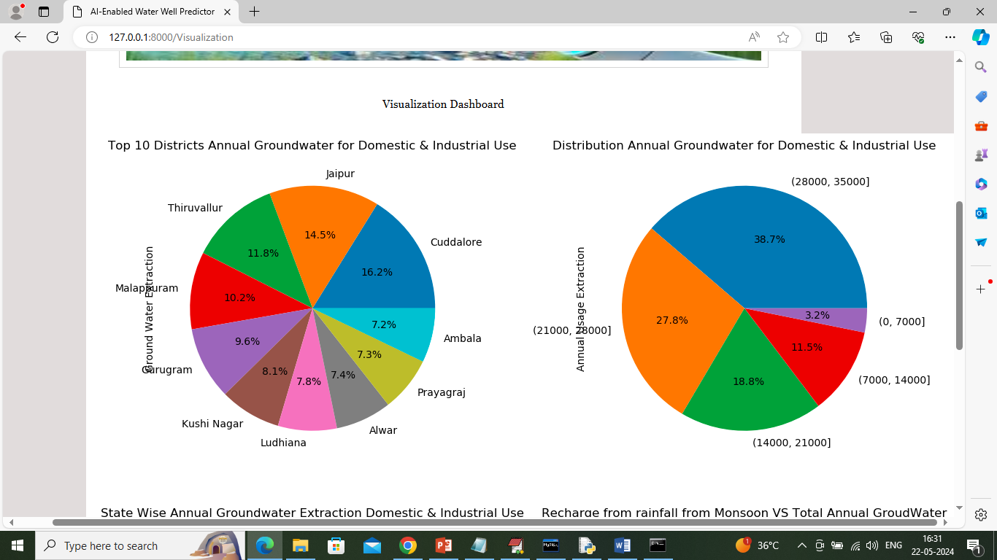

In above screen in first graph can see district wise water consumption and in second graph can see Litre wise water consumption

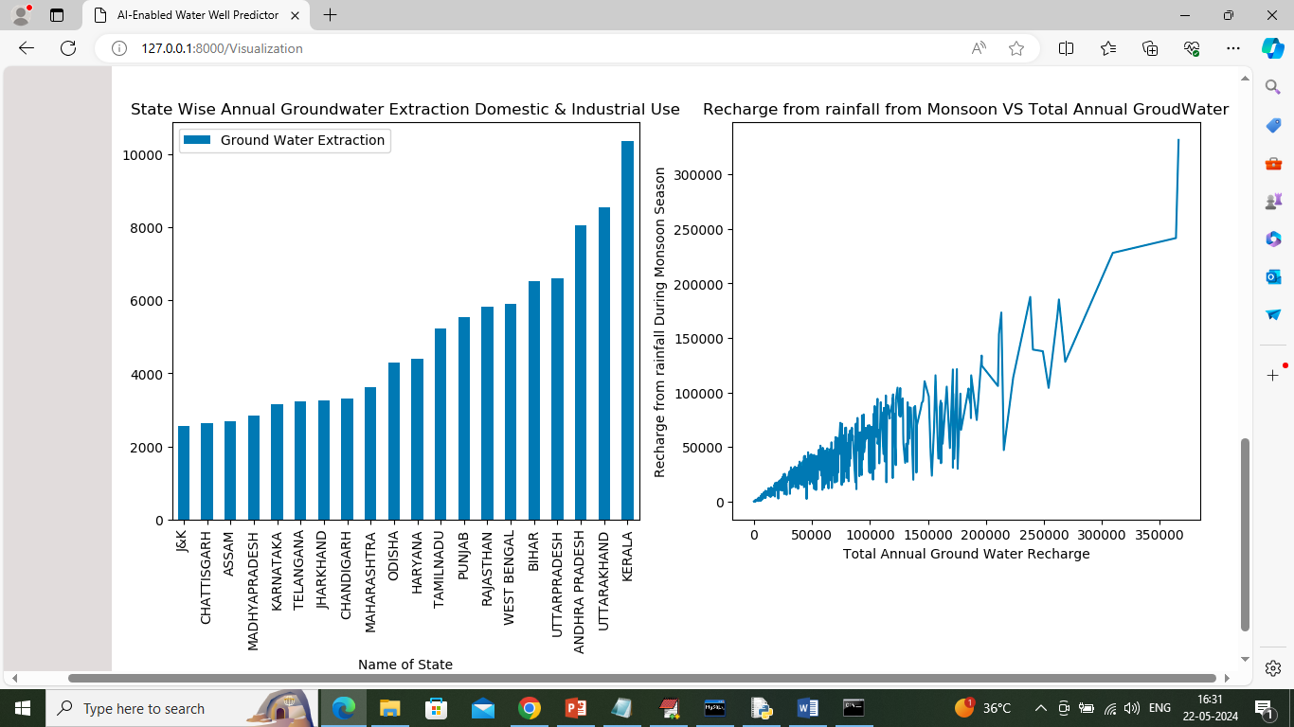

In above screen first graph represents ‘State’ wise water consumption and second graph represents Ground water recharge where x-axis represents ‘Annual Ground Water Recharge’ and y-axis represents recharge from monsoon. Now click on ‘Clustering K-means’ link to group dataset into similar cluster and get below output

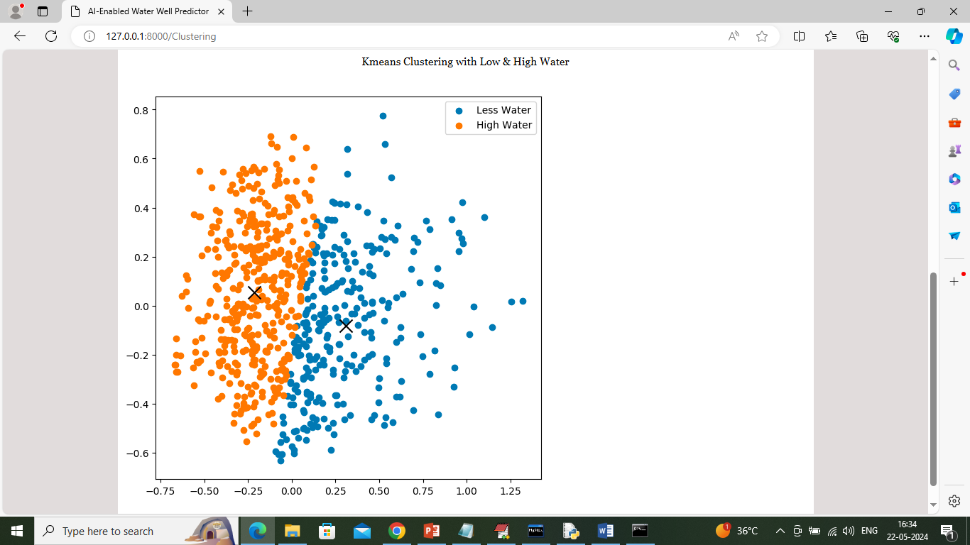

In above graph x and y-axis represents data points from dataset and then all same colour dots consider as one cluster which has similar data points and in above graph orange dots represents states with high water and blue dots represents states with High water and now click on ‘Train Models’ link to train ML algorithms and calculate metrics

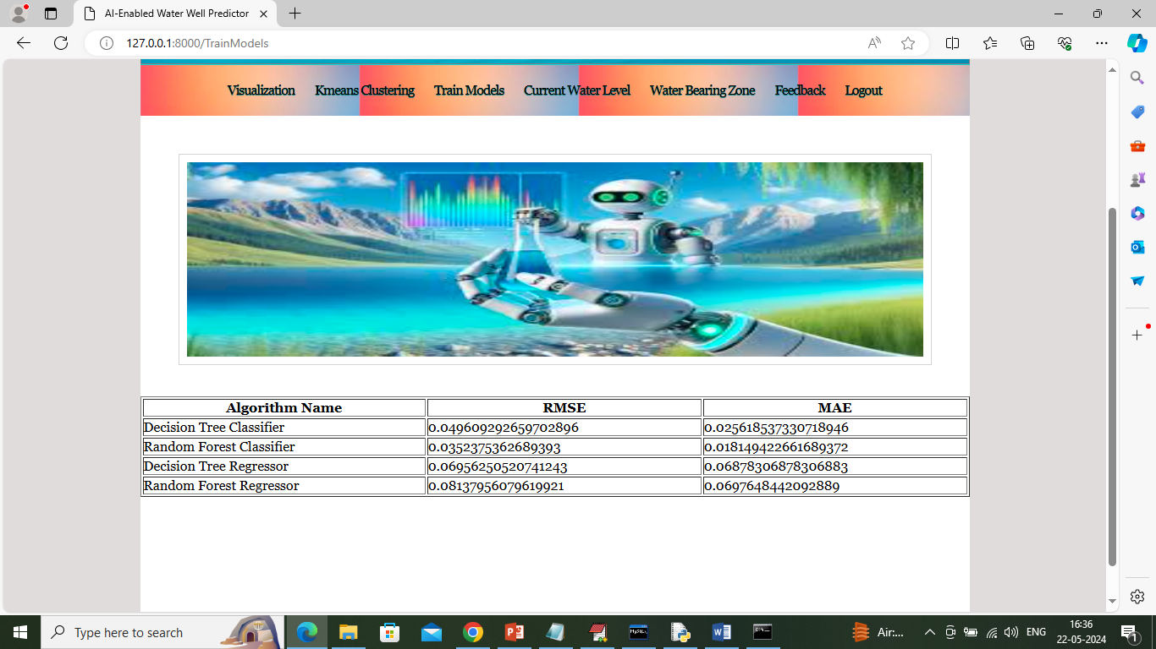

In above screen we trained decision tree and random forest on well and monsoon datasets with classifiers and regressor and then evaluate each algorithm performance in terms of RMSE and MAE. RMSE (root mean square error) and MAE (mean absolute error) refers to difference between True and predicted values from test data so the lower the difference the better is the algorithm and in above tabular result we can see decision tree got less RMSE and MAE so decision tree is better than random forest.

Now click on ‘Current Water Level’ link to forest water level by taking input values

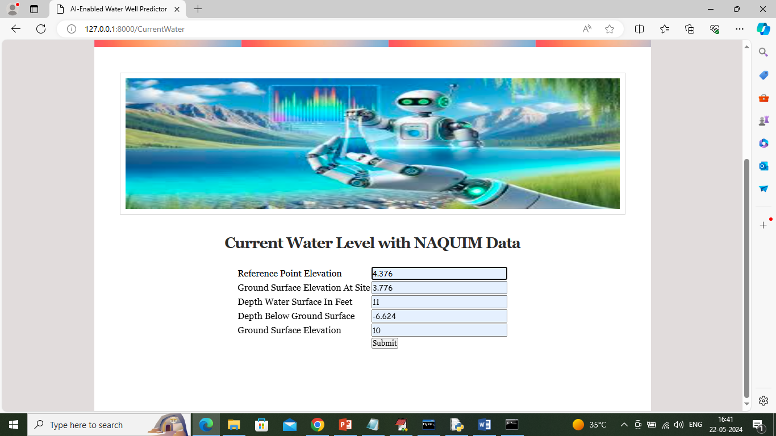

In above screen enter current NAQUIM data and then press button to get below forecast water level

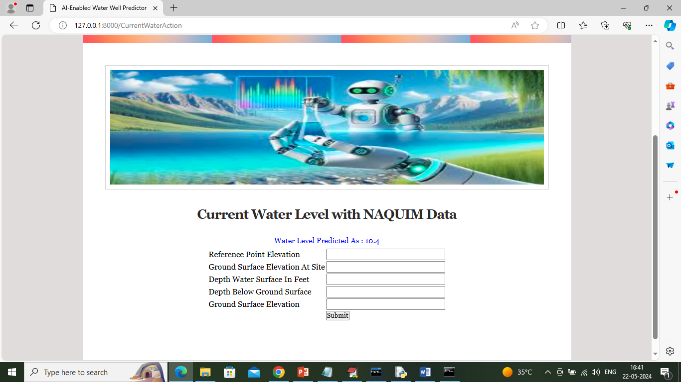

In above screen in blue colour text can see water level predicted as 10.4 and now click on ‘Water Bearing Zone’ link to get below page

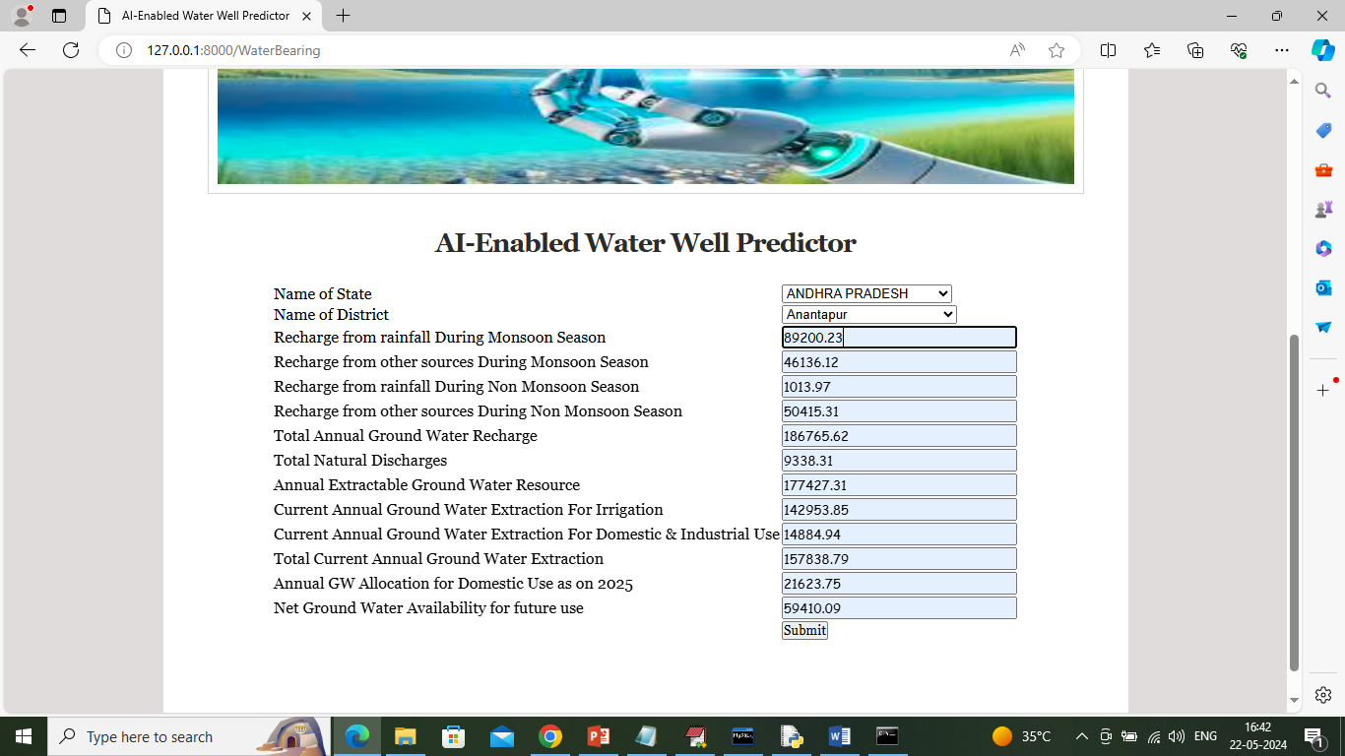

In above screen enter current WELL details and then press button to predicted water level like below screen

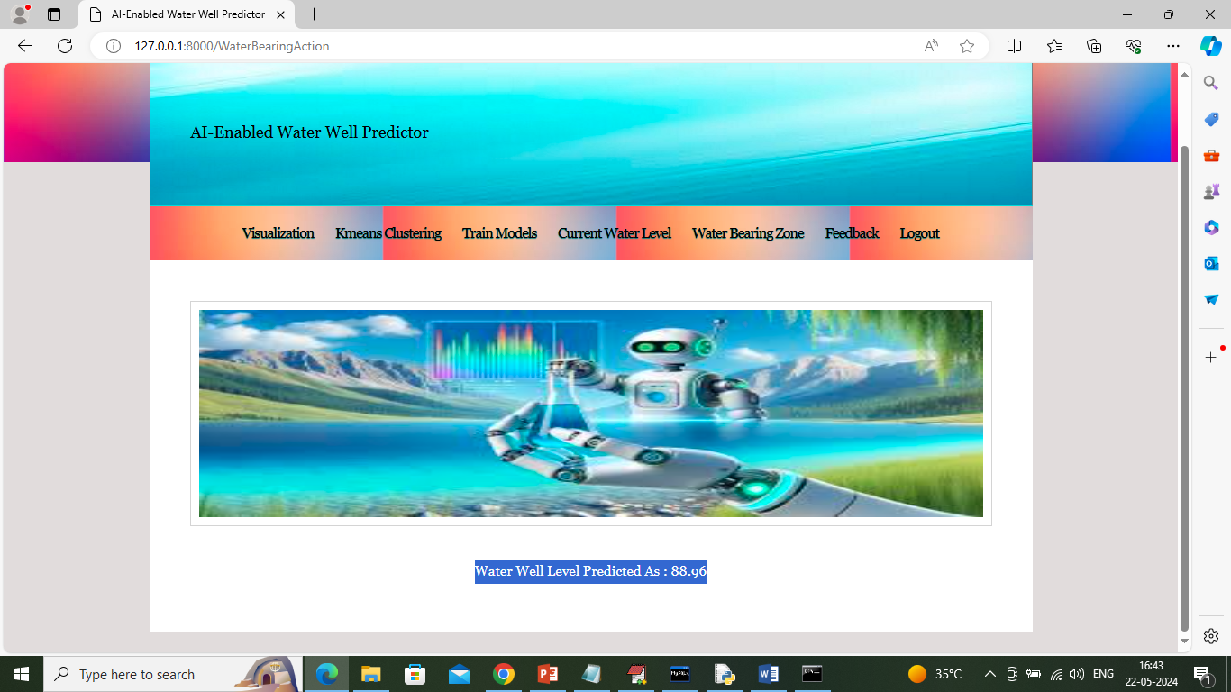

In above screen in blue colour text can see ‘Water level in well predicted as 88.96’ and now click on ‘Feedback’ link to get below page

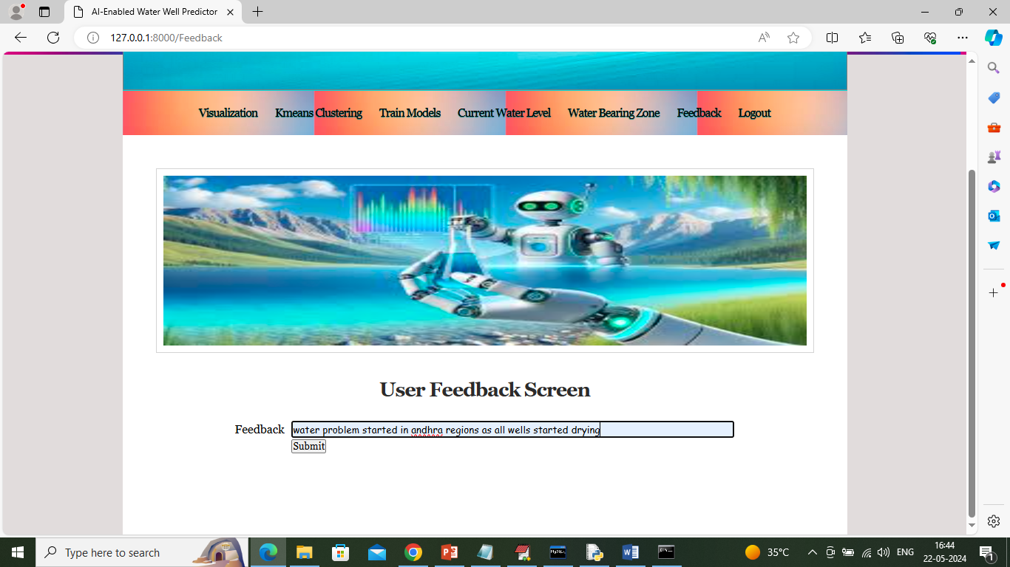

In above screen user will enter some feedback and then application will employ NLP algorithms to analyse feedback patterns and detect sentiments and give below output

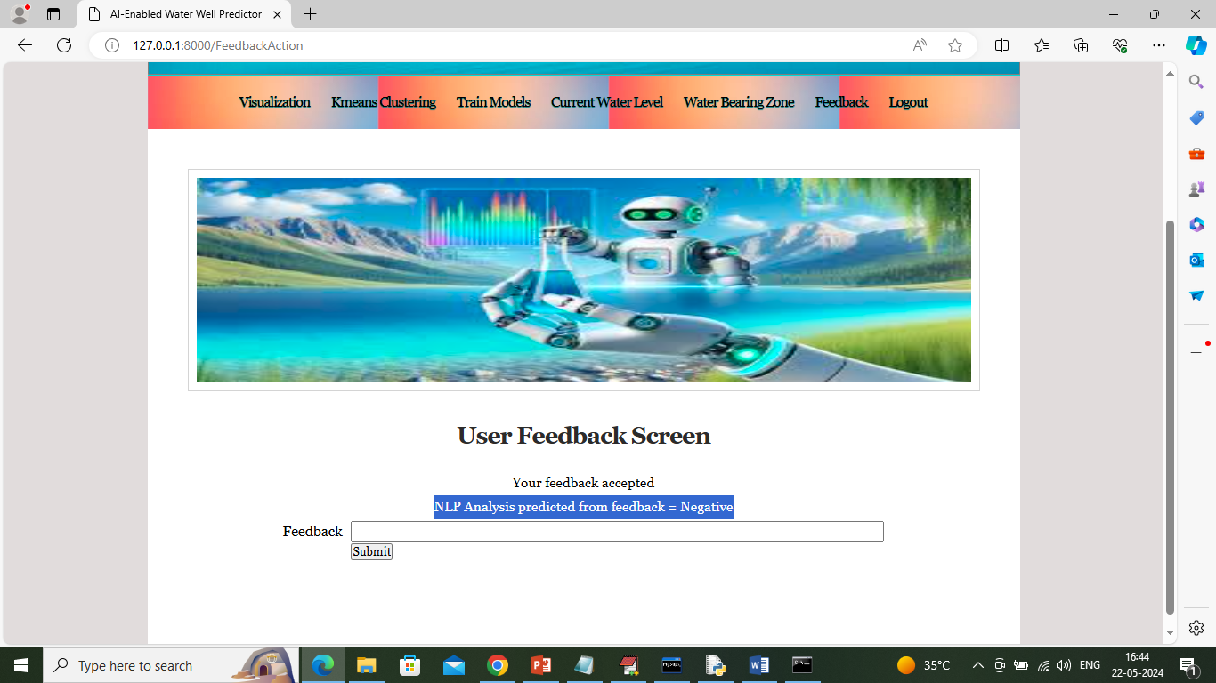

In above screen based on user feedback NLP detected sentiments as ‘Negative’.

Similarly by following above screens you can run entire project